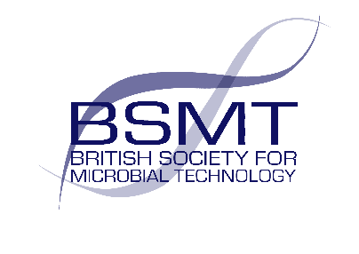
Announcement of new BSMT Chair 2025

We are delighted to announce David Westrip as the new Chair of the BSMT committee taking over the role from Dr Mark Wilks. We thank Mark for the exemplary leadership he has given the committee over the last few years.
David Westrip is a Senior Biomedical Scientist in Microbiology. After graduating from the University of Kent, David initially worked in a commercial food and water testing laboratory whilst completing his MSc through the LSHTM. He achieved HCPC registration whilst training at the Luton and Dunstable Hospital and since then has worked in South London and Western Sussex NHS Trusts covering a variety of Biomedical Scientist roles. Currently working in East Kent his current role as Microbiology Training Manager allows him to combine his enthusiasm for the development of other laboratory staff with maintaining an active role on the bench.
David has been a BSMT committee member since 2021 and brings with him his recent experience as the Deputy Chair of BSMT.

