British Society for Microbial Technology Symposium
“Rapid Diagnostics – Time is Relative”
18 May 2018

Evaluation Report

A total of 102 paying delegates, 12 committee members, 8 speakers/chairs, 5 guests and 26 trade representatives (a total of 153 requiring lunch) attended the BSMT Annual Meeting held at PHE Colindale on 18 May 2018. In addition to this, a small number of delegates had submitted application forms, but did not progress their submission. Two delegates received refunds, three have yet to pay and three delegates paid but did not attend. Forty delegates (29%) returned a completed evaluation form. The results presented in this report are based on the 40 returned forms.

Content of the Day
The majority (93%, 37/40) of delegates scored the content and structure of the day as good or very good, and scored the day to have mostly to fully met their expectations. The remaining three delegates did not provide a score. All the delegates rated the relevance of topics, as well as the usefulness of the content in their work, as either average, good or very good. No delegates scored the meeting content below average.

Presentations and Discussions
Figure 2a shows the evaluation scores given for the individual presentations. Of all the delegates who gave a score, (98%) 39/40 rated the presentations as average, good or very good with one delegate giving a rating of poor. Up to 2 delegates did not provide a score.

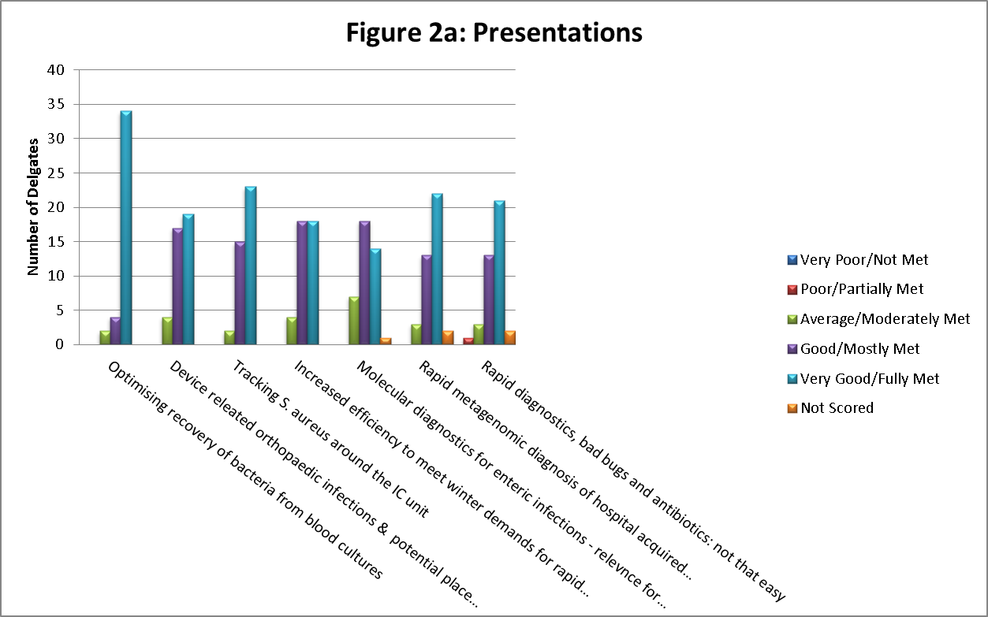

Figure 2b shows the evaluation scores given for the morning and afternoon panel discussions. The morning session was evaluated by the majority of delegates (98%) 39/40 as average, good or very good. One delegate did not provide a score for this session. 33 delegates (83%) scored the afternoon discussion as either average, good or very good, with 7 delegates (18%) not providing a score

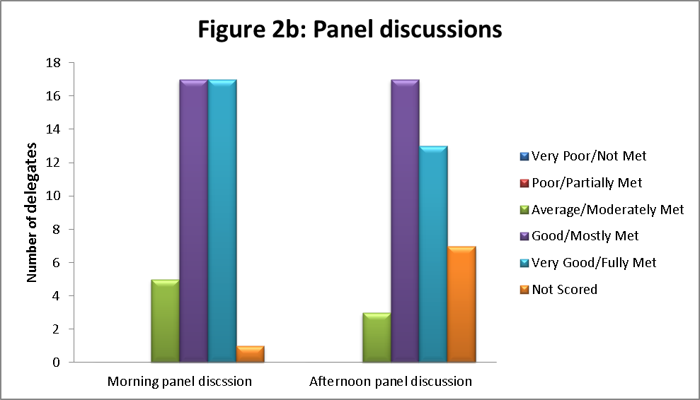

Venue, General Administration and Delegate Pack
The majority of delegates (39/40, 98%) evaluated the venue, general administration and delegate pack as either average, good or very good. One delegate did not give a score (Figure 3).

Thirty-nine delegates (39/40, 98%) rated their registrations as having been handled in an average, good or very good way. One delegate did not give a score.

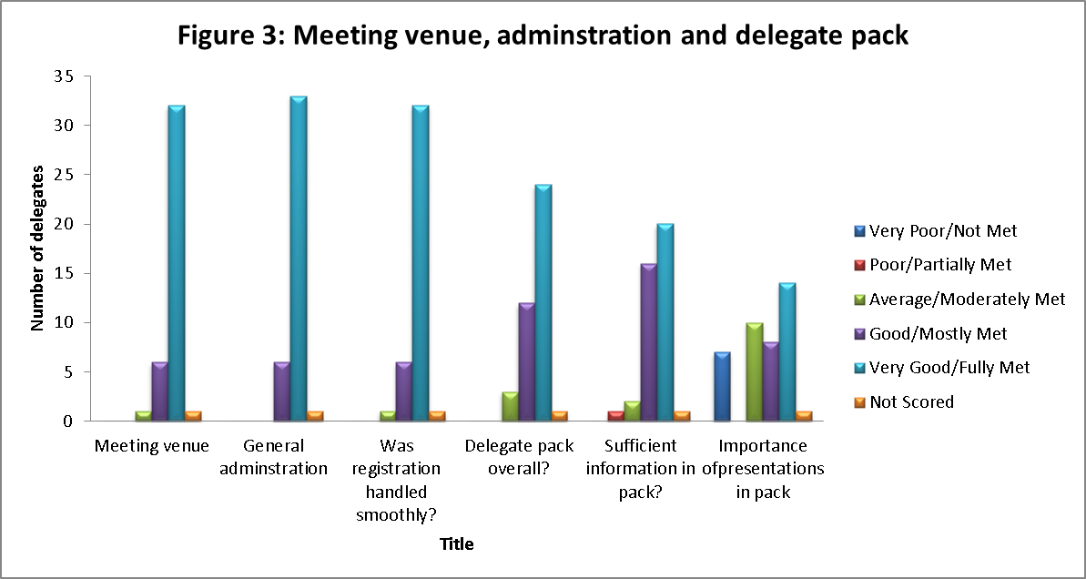

BSMT Education Grants
Of the 40 delegates who were asked, 11 delegates (28%) were aware that the BSMT offered Education Grants, 27 delegates (67%) were not, and 2 delegates (5%) did not answer. Of these, 12 delegates said that they would be interested in applying for the grant, 3 delegates said maybe and 12 delegates said no. Thirteen delegates did not give an answer. The reasons given for not being interested in applying for the BSMT Education Grant were as follows:

Lab is very specific to blood products
Not sure if grant suitable for overseas staff
Not lab based

Social Media
22/40 (55%) delegates said that they were aware that they could receive regular update on the BSMT Twitter and Facebook account. 16/40 (40%) delegates were not aware and two did not answer the question.

35/40 (88%) delegates said they do not follow BSMT on Twitter and Facebook and 3/40 (8%) delegates said they did follow. Two delegates did not answer this question

Additional Comments
All delegates were asked to provide additional comments in the form of free text. A selection of these has been provided below:

Presentations on website so less paper
More paper presentation so you can annotate slides
Copies of all presentations
Not sure pack is needed
Paper copies of all presentations or on a stick
Much better with less commercial material
Receive presentations by email

Most enjoyed
Range of talks and speakers
Content of presentations
Morning lectures
Everything but particularly Gemma Clark and Justin O’Grady’s presentations
Varied and interesting topics
Dr Grant’s talk
Good range of seminars and great food
Good number of talks, good balance and speed. Nice lunch
Blood culture and orthopaedic lectures were very useful
Clarity of presentations and links to operational issues
Blood cultures / sepsis talk
NGS related seminars
Topics and organisations skills of committee
Clinical slants of most talks
Energy of crown
Networking, tight connection between talks
Good update on molecular / diagnostic issues and how to apply

Least enjoyed
Travel
Lunch/break and some of presentations too long
Viruses lecture as not relevant to my role
Speakers talking fast with no handouts
Finding parking
Food
Could start a bit earlier
Late lunch
Slightly too much time between sessions, possibly compress or add more speakers
More audience participation, quiz
Shorten lunch and trade shows

Please tell us your main reason for attending
Hear about current tech
Topics
Enteric diagnotics
To remain updated
Interesting subjects
Education
Good speakers
Enjoyment
New advances and changes
CPD credit
Gain knowledge relevant to field
Want to introduce rapid diagnostics
One of the best meetings around , always current

How could we improve the meeting?
Wifi
More central venue
Longer time for presentations
More lectures like Dancer’s, lectures applicable and introducible to routine lab to impact workflows
Presentations on white backgrounds easier to read
Bigger area for trade show
More audience participation

Where did you hear about the meeting?
Email
From colleague
Offer at work
Notifications to senior management
Facebook
BSMT website
From line manager
Attend every year
PHE intranet
PHE weekly bulletin

Any other comments
Thumbs up, keep doing what you are doing
Excellent day, very useful
Lunch worked well
Would like clarification if grant is suitable for international healthcare staff
Food was great and organisation was excellent
Would like lectures sent via email
Excellent location, speakers, refreshments and day/time
Looking forward to next meeting
It should have more talks or presentations in future BSMT conference about what medical microbiology labs can do practically through molecular biology not just potential development

