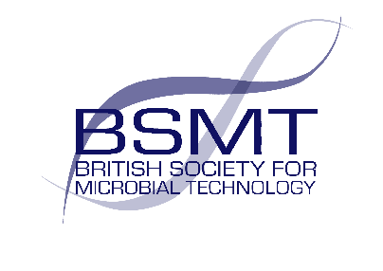
The 2024 conference was dedicated to the memory of Mahsa Amini
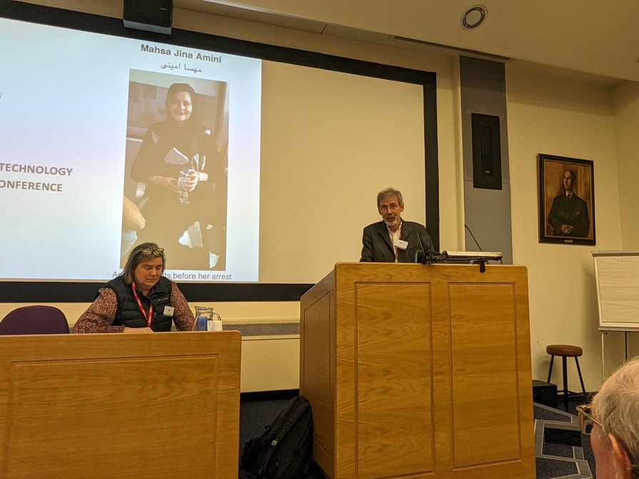
Mahsa Amini, an Iranian student about to start a degree in Microbiology but was arrested on 13 September 2022 for ‘improperly wearing the mandatory head covering’; she died in police custody several days later.
We offered several grants in memory of Mahsa Amini aimed at potential delegates who would otherwise not be able to attend the BSMT conference due to financial reasons. The grant is for the registration fee and/or the cost of travel (standard rate). To apply for the grant, a short summary (one side of A4) of the reasons were sent to BSMT Chair, Dr Mark Wilks (mwilks@bsmt.org.uk). The applications were assessed by a subgroup of the BSMT committee.

